Applied Programming POE
ST10447209 Shenice Woods
ST10458840 Maanda Nethavhani

Unit Test in Visual Studio
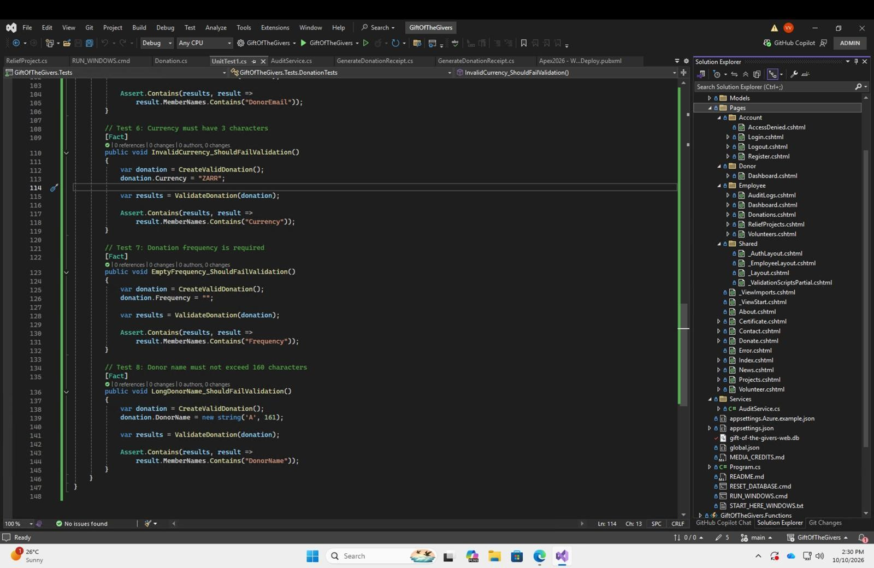
Figure 1: Unit test code in Visual Studio
Description: The UnitTest1.cs file in the GiftOfTheGivers.Tests project, showing Tests 6 to 8: InvalidCurrency_ShouldFailValidation (currency "ZARR" is longer than 3 characters), EmptyFrequency_ShouldFailValidation (frequency set to an empty string) and LongDonorName_ShouldFailValidation (a 161-character donor name). Each is marked [Fact] and the Solution Explorer on the right shows the project's Pages, Services and Shared folders.
Explanation: Each test builds a valid donation, changes one property to break a validation rule, and uses Assert.Contains to confirm the validator reports an error for that exact property. This proves the Donation model's data-annotation rules (currency length, required frequency, maximum donor name length) reject bad input.

Integration Test
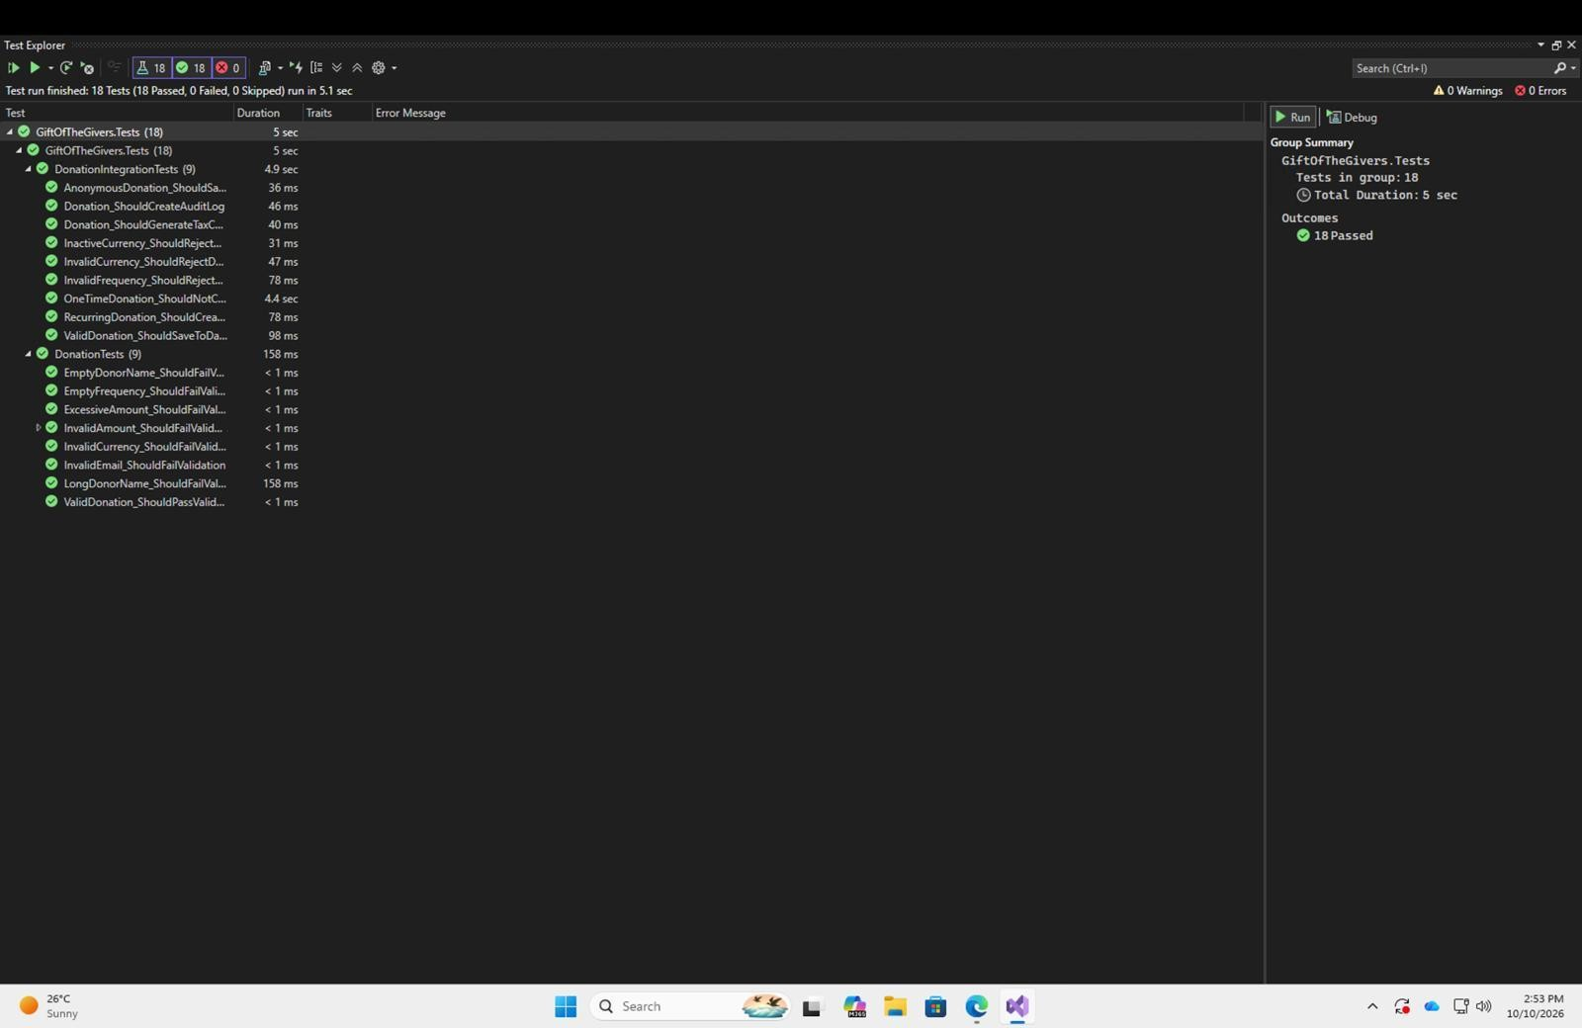
Figure 2: Integration tests passing in Test Explorer
Description: Visual Studio's Test Explorer after a full run: 18 tests, 18 passed, 0 failed, 0 skipped, in about 5 seconds. They are split between DonationIntegrationTests (9 tests, 4.9 s) and DonationTests (9 tests, 158 ms).
Explanation: The integration tests (for example ValidDonation_ShouldSaveToDatabase, Donation_ShouldCreateAuditLog, RecurringDonation_ShouldCreate...) check that the donation workflow works end to end with its database and audit logging, not only the model validation. The green ticks are the evidence that the whole logic layer behaves as designed.

Graphana k6 Load and Stress Testting
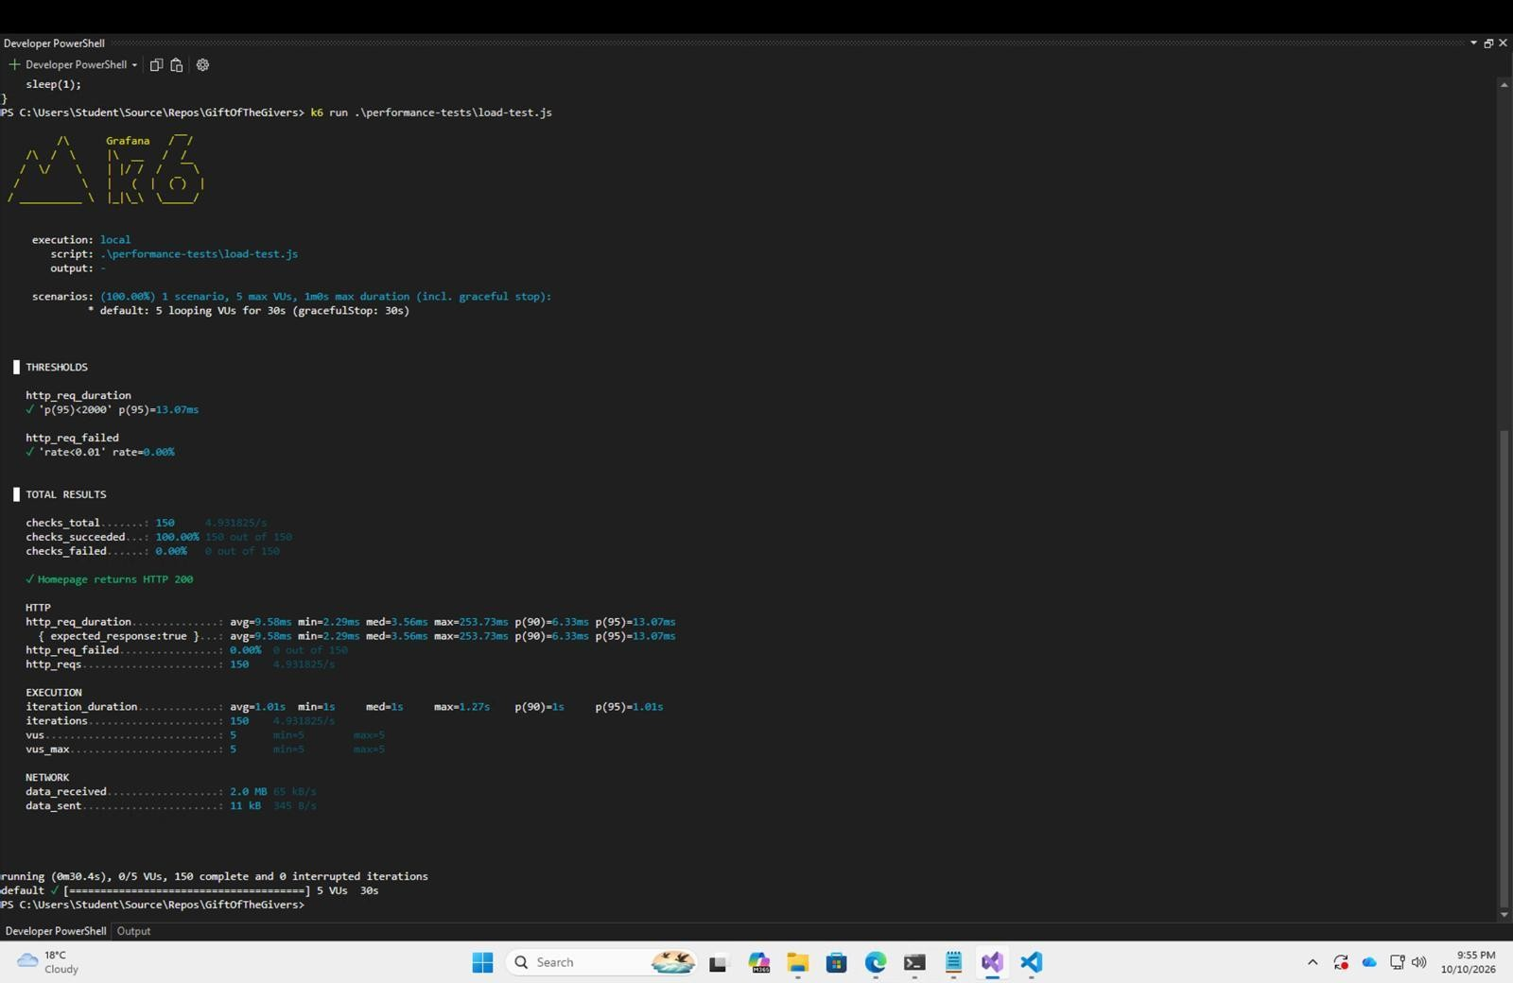
Figure 3: Grafana k6 load test results
Description: The Developer PowerShell running k6 run .\performance-tests\load-test.js with 5 virtual users (VUs) looping for 30 seconds. The summary shows 150 requests, 100% of checks passed ("Homepage returns HTTP 200"), 0.00% failed requests and a 95th-percentile response time of 13.07 ms.
Explanation: A load test applies a normal, steady amount of traffic. Both thresholds were met (p95 under 2000 ms and failure rate under 1%), so the application handles typical concurrent use comfortably and responds far faster than the limit set.
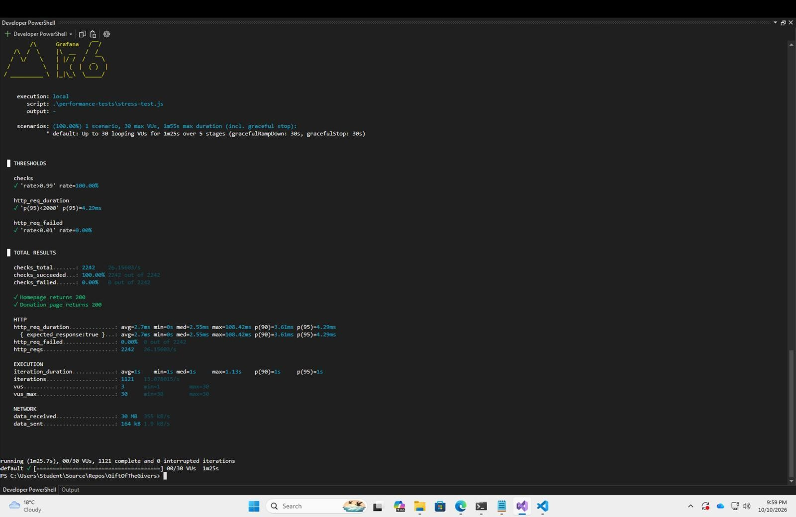
Figure 4: Grafana k6 stress test results
Description: The output of k6 run .\performance-tests\stress-test.js, which ramps up to 30 VUs over 5 stages (about 1 minute 25 seconds). It made 2,242 requests to the homepage and donation page with 100% of checks passed, 0.00% failures and a 95th-percentile response time of 4.29 ms.
Explanation: A stress test pushes the site beyond normal traffic to see whether it degrades or breaks. All thresholds still passed at 30 concurrent users, showing the application stays stable and fast as load increases.

Selenium UI Testing
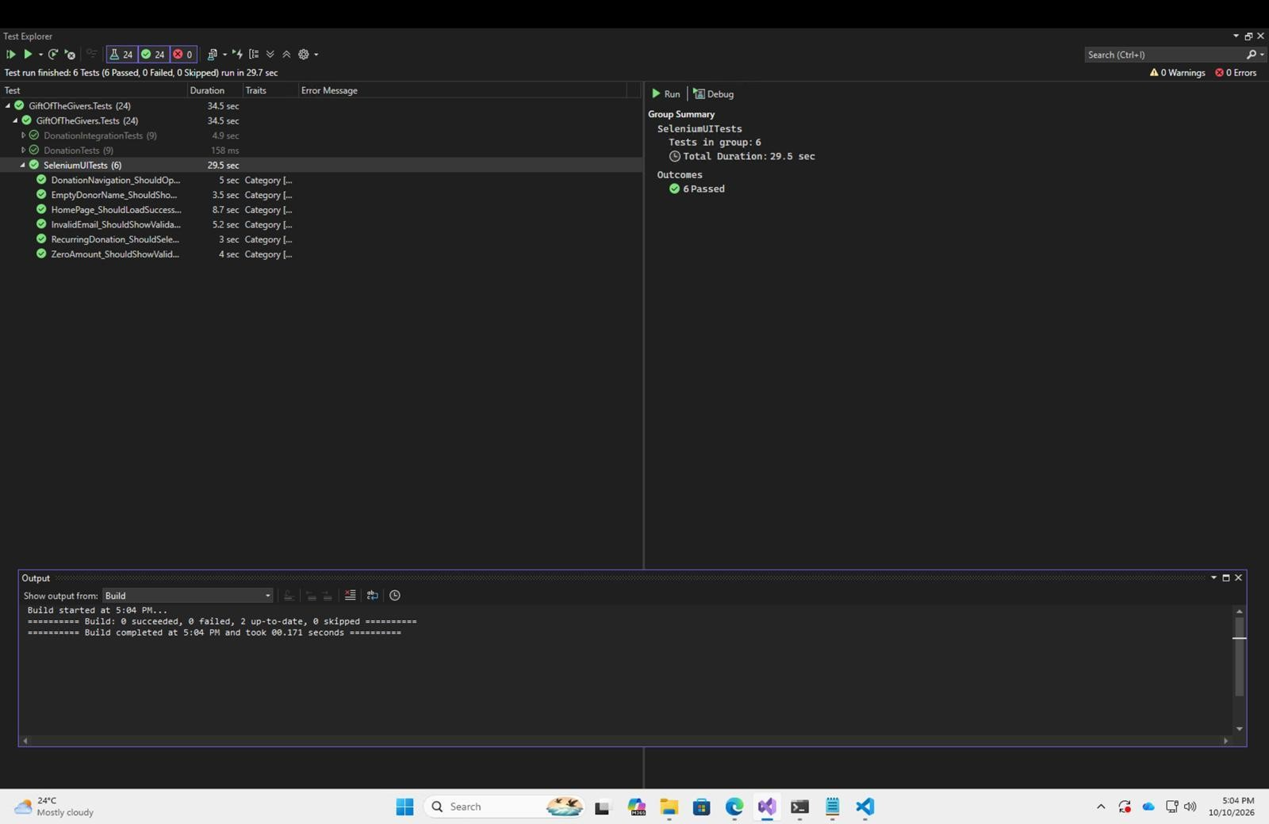
Figure 5: Selenium UI tests passing
Description: Test Explorer showing the SeleniumUITests group: 6 tests passed in about 29.7 seconds (DonationNavigation, EmptyDonorName, HomePage, InvalidEmail, RecurringDonation and ZeroAmount). The overall total is now 24 passed, 0 failed, and the Output window shows a successful build.
Explanation: These tests drive a real browser to check the donation pages the way a user would: loading the home page, navigating to the donation form and confirming that invalid input (empty name, bad email, zero amount) shows validation messages. They are tagged with the category "UI" so they can be run separately from the other tests.

Integration Tests into Azure Pipelines
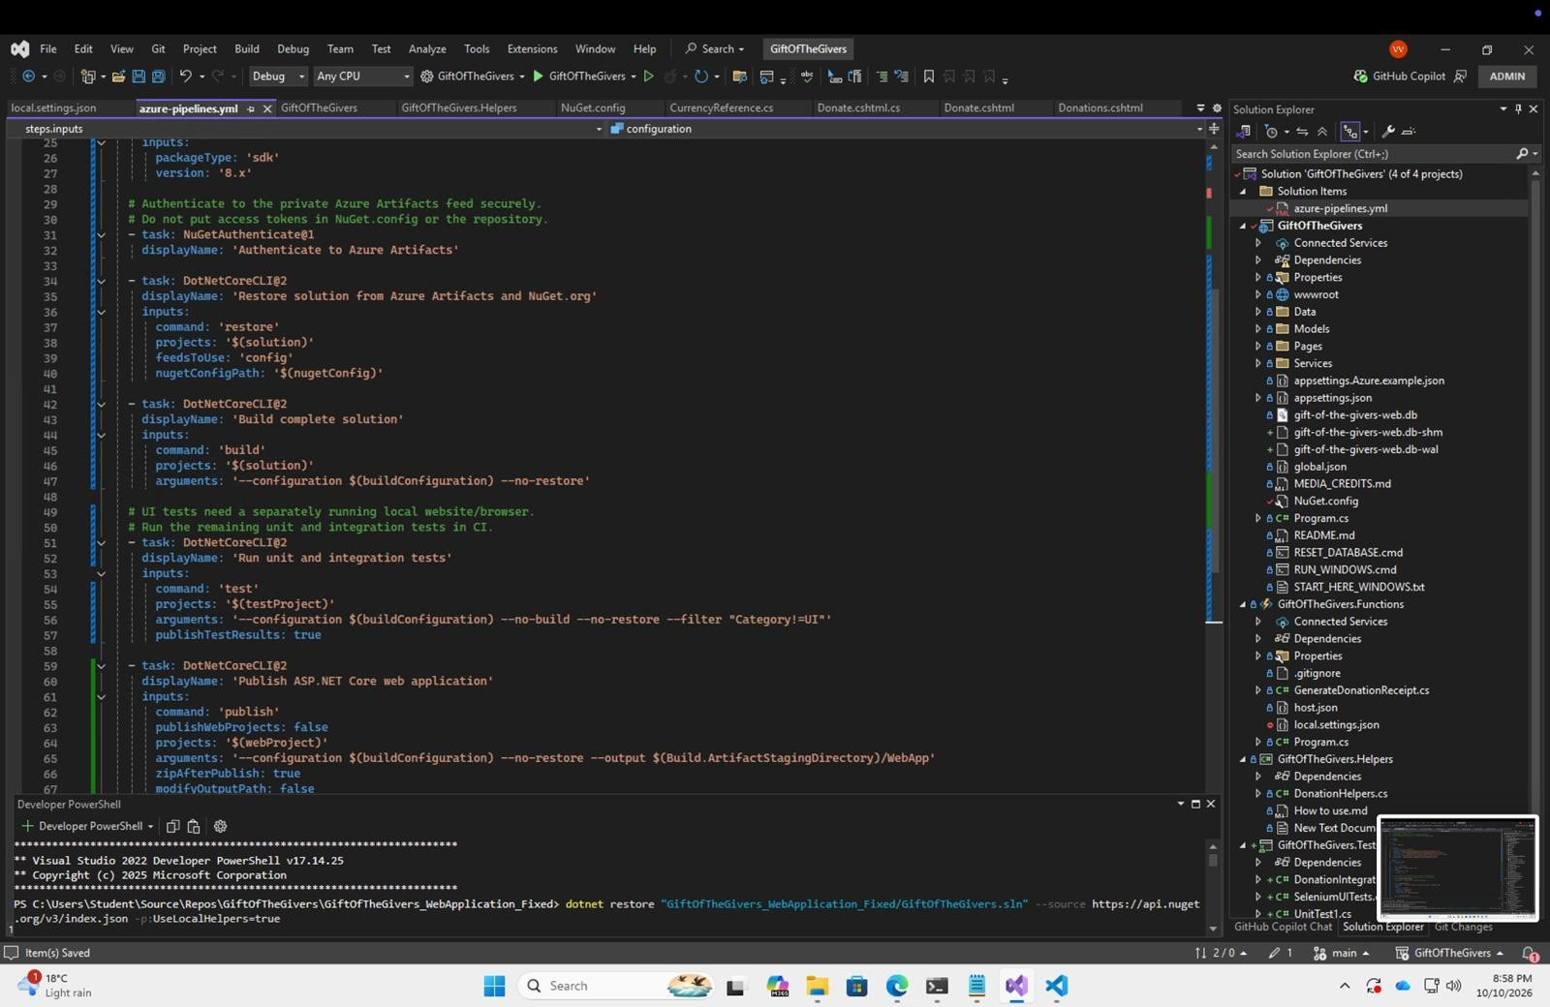
Figure 6: Azure Pipelines YAML file in Visual Studio
Description: The azure-pipelines.yml file open in Visual Studio, showing the middle of the pipeline: NuGetAuthenticate@1 to sign in to the private Azure Artifacts feed, a DotNetCoreCLI restore, a build of the whole solution, and a test step that runs with --filter "Category!=UI".
Explanation: This is the pipeline definition that runs automatically in Azure DevOps. The comments explain that no access tokens are stored in NuGet.config, and that the UI tests are excluded in the pipeline because they need a locally running website and browser. Only the unit and integration tests run in CI, with results published (publishTestResults: true).

Successful git Push and Azure Repos
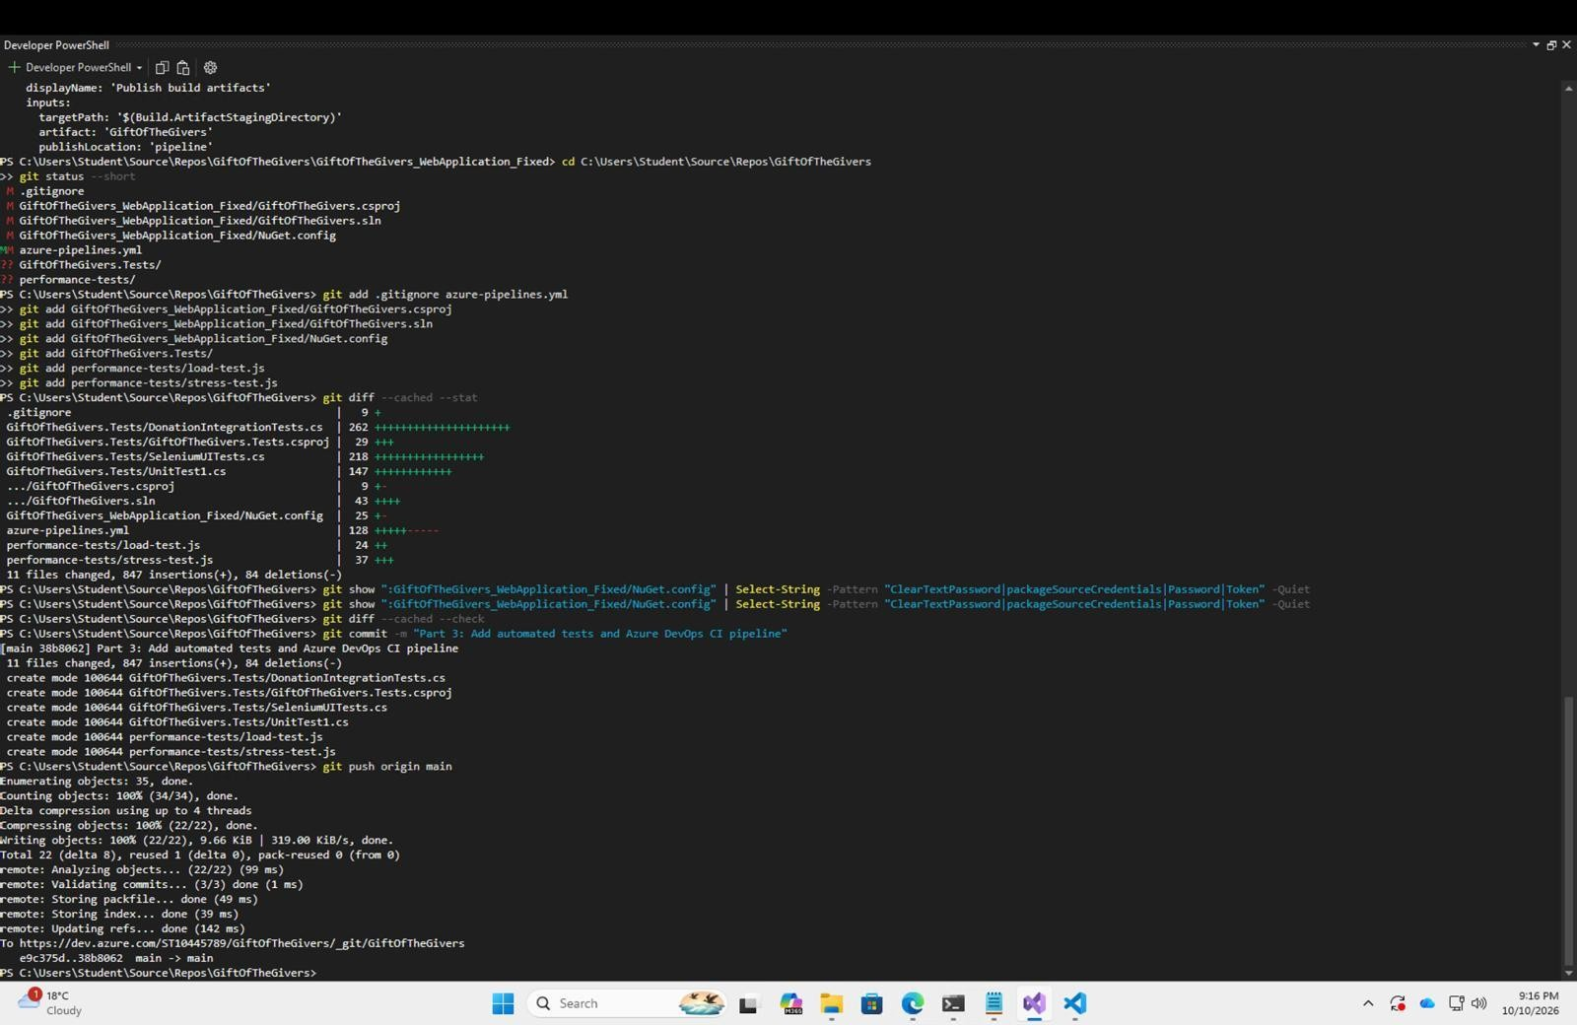
Figure 7: Committing and pushing to Azure Repos
Description: Developer PowerShell showing git status, git add for the changed files, git diff --cached --stat (11 files changed, 847 insertions), a search of NuGet.config for passwords or tokens, git commit with the message "Part 3: Add automated tests and Azure DevOps CI pipeline", and a successful git push origin main to dev.azure.com.
Explanation: This is the step that sends the new test projects, k6 scripts and pipeline file to Azure Repos. Pushing to the main branch triggers the CI pipeline. The Select-String check and git diff --check confirm that no credentials or whitespace errors were committed.

Unit Tests Passed
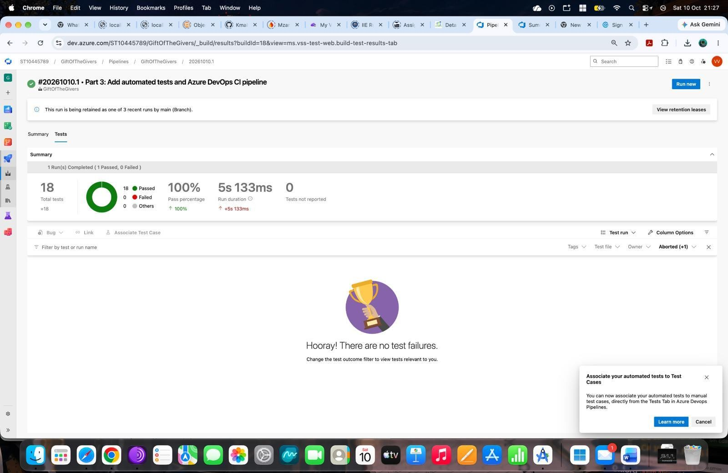
Figure 8: Unit tests passed in the Azure pipeline
Description: The Tests tab of pipeline run #20261010.1 ("Part 3: Add automated tests and Azure DevOps CI pipeline") in Azure DevOps: 18 total tests, 100% pass rate, 0 failed, run duration 5 s 133 ms, and the message "Hooray! There are no test failures."
Explanation: This confirms the same 18 tests that passed locally also pass on the build agent, so the CI pipeline correctly builds the solution and runs the automated tests on every push.

Artifacts published
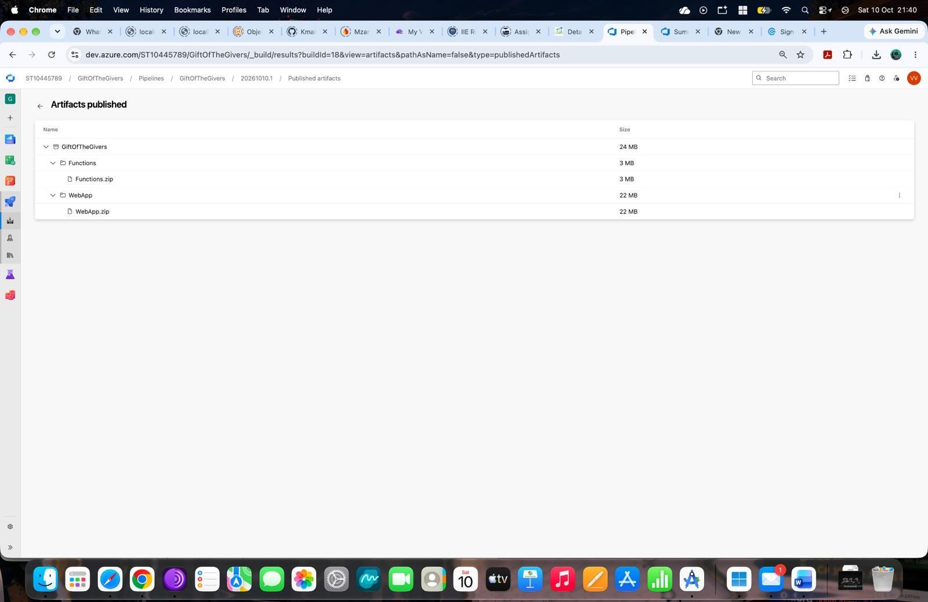
Figure 9: Build artifacts published by the pipeline
Description: The Published artifacts page for the pipeline run, listing the GiftOfTheGivers artifact (24 MB) containing Functions/Functions.zip (3 MB) and WebApp/WebApp.zip (22 MB).
Explanation: After a successful build and test run, the pipeline packages the Azure Function and the ASP.NET Core web application as zip files. These are the deployable outputs that can be released to Azure.

App Service Deployment
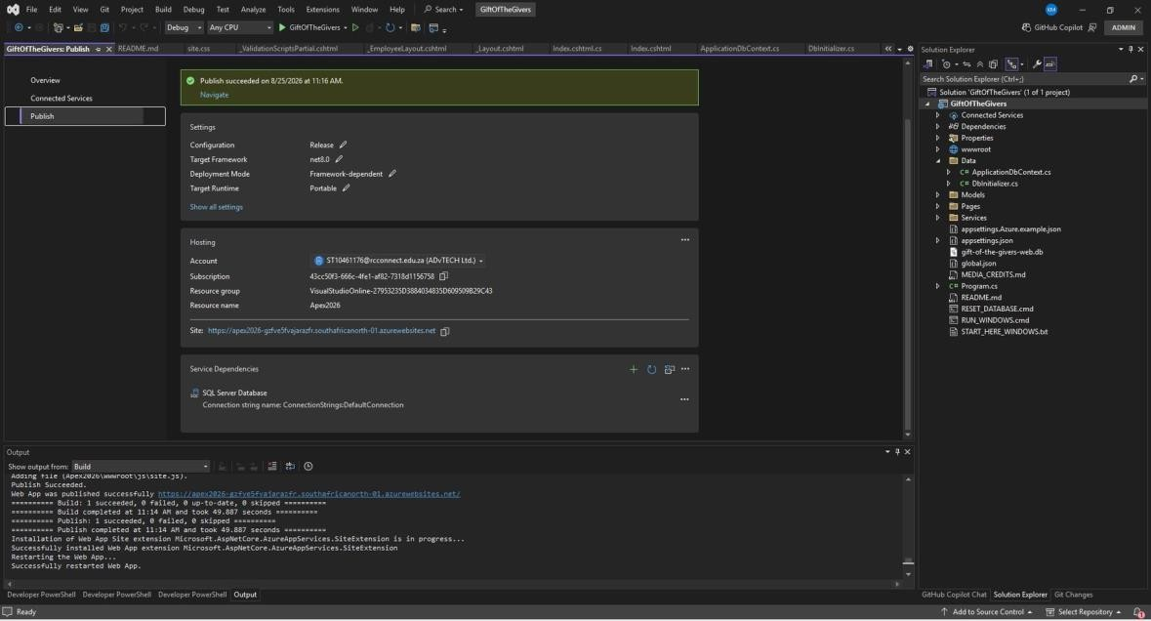
Figure 10: Publishing the web app to Azure App Service
Description: The Visual Studio Publish page showing "Publish succeeded". The profile uses the Release configuration, net8.0, framework-dependent deployment and the Portable runtime. It is hosted on the Azure App Service "Apex2026" and depends on a SQL Server database. The Output window confirms "Web App was published successfully" and that the web app was restarted.
Explanation: This is evidence that the web application has been deployed to Azure and is available online at the azurewebsites.net address shown, with its database connection string configured.
Functions Upload
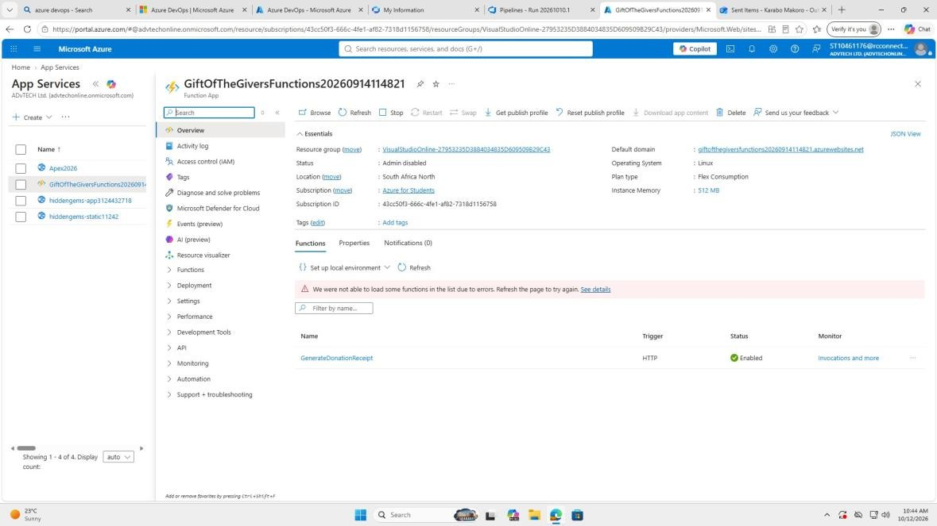
Figure 11: Azure Function App and functions upload
Description: The Azure portal overview of the Function App GiftOfTheGiversFunctions (Linux, Flex Consumption plan, South Africa North). The Functions list shows GenerateDonationReceipt with an HTTP trigger and status Enabled.
Explanation: This shows the Azure Function that generates donation receipts has been uploaded and deployed, and is ready to be called over HTTP. The red banner is the portal reporting that it could not load some function details and asking for a refresh.

SQL Deployment
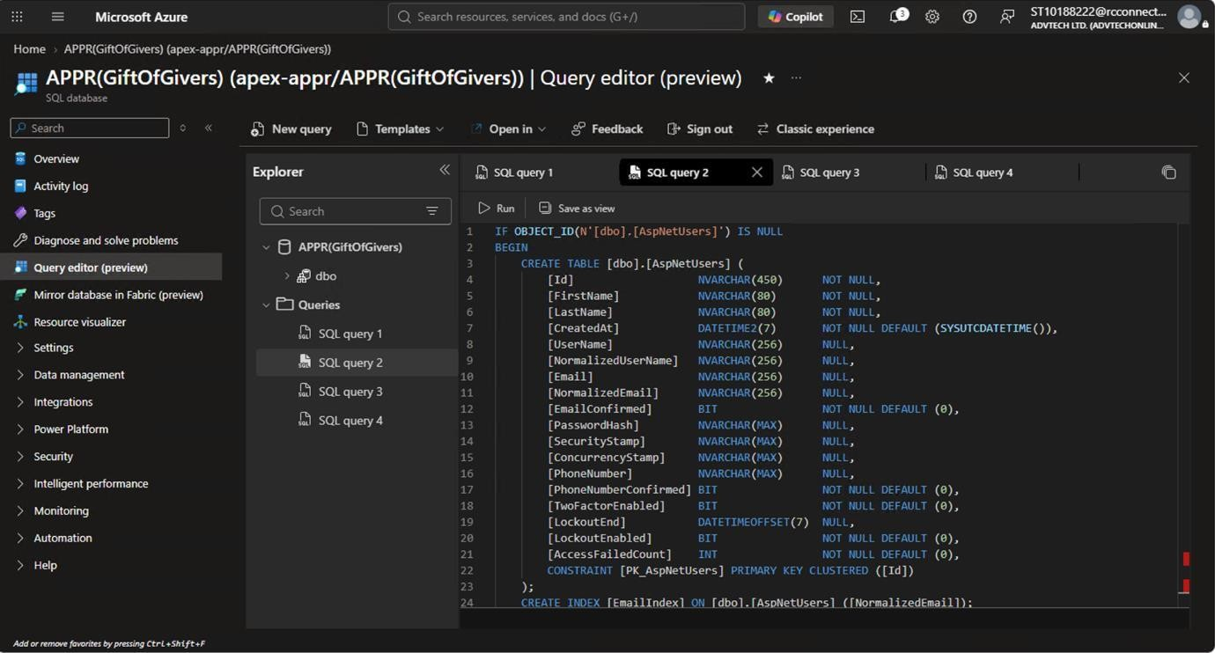
Figure 12: SQL deployment: creating the database tables
Description: The Azure SQL Query editor (preview) on the database APPR(GiftOfGivers), with SQL query 2 open. The script creates the dbo.AspNetUsers table if it does not already exist, with columns such as Id, FirstName, LastName, Email, PasswordHash and LockoutEnd, a primary key, and an index on NormalizedEmail.
Explanation: This script creates the ASP.NET Identity user table that the application's login and registration need. The IF OBJECT_ID ... IS NULL check makes it safe to run more than once.
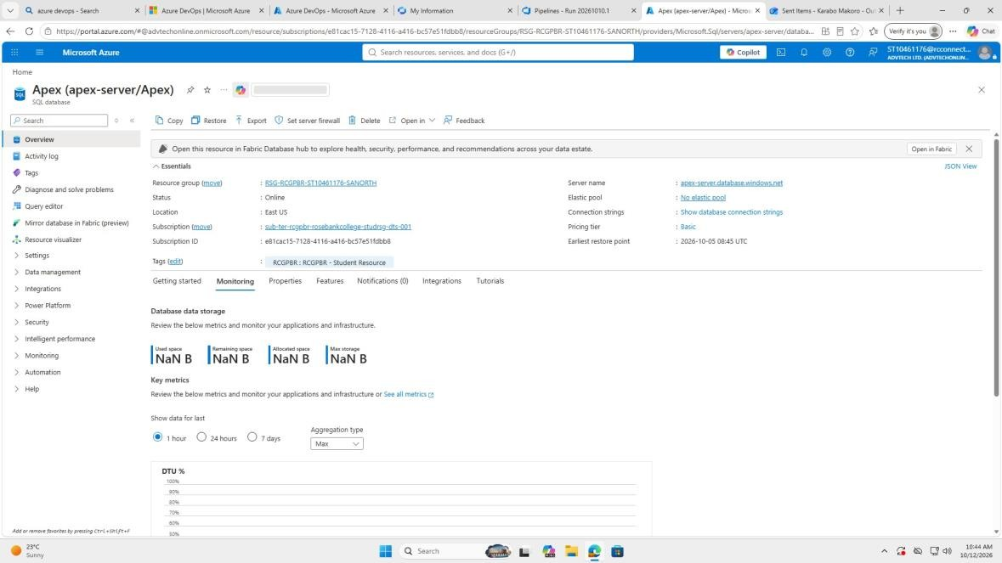
Figure 13: Azure SQL database overview
Description: The Azure portal overview for the SQL database Apex on server apex-server.database.windows.net. The status is Online, the pricing tier is Basic, and the Monitoring tab shows storage and DTU graphs.
Explanation: This confirms the cloud database exists and is running. The storage values show NaN B because no monitoring data had been collected yet in the selected 1-hour window.

xUnit Test Project

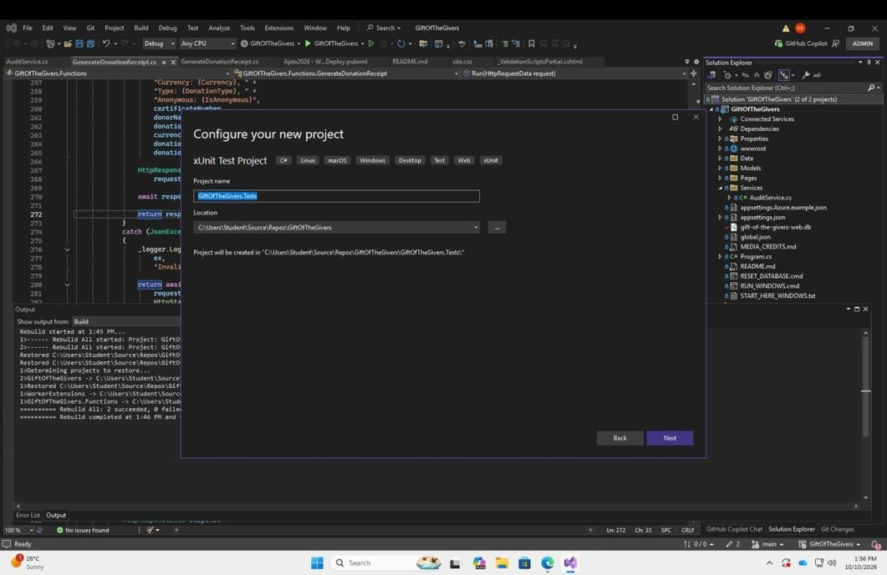
Figure 14: Creating the xUnit test project
Description: The Visual Studio "Configure your new project" screen for an xUnit Test Project (C#), with the project name GiftOfTheGivers.Tests and its location in C:\Users\Student\Source\Repos\GiftOfTheGivers.
Explanation: This is the first step in setting up automated testing. xUnit is the testing framework used, and the separate test project keeps the test code apart from the application code.

Test Dependancy
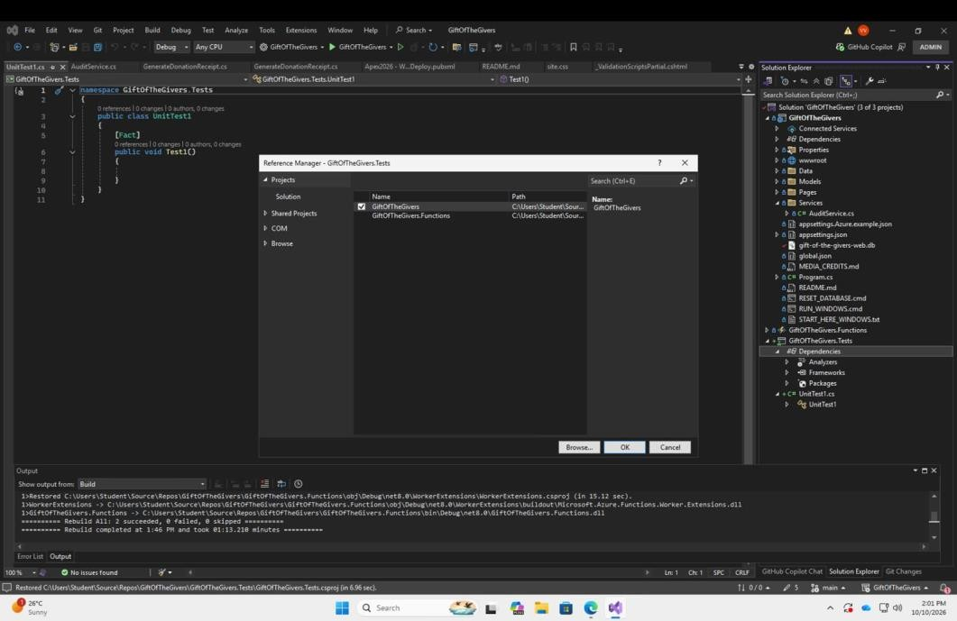
Figure 15: Adding the project reference (test dependency)
Description: The Reference Manager for GiftOfTheGivers.Tests with the GiftOfTheGivers project ticked under Projects. The default UnitTest1.cs template with an empty [Fact] method is open behind it.
Explanation: The test project needs a reference to the web application so it can use the real Donation model and services. After this, the Dependencies node of the test project lists the main project.

Unit Test Methods
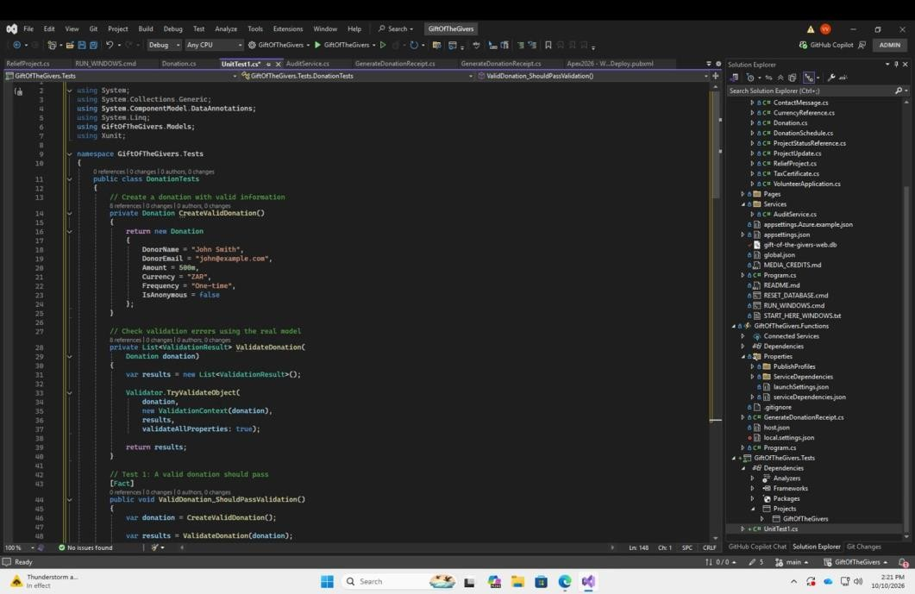
Figure 16: Unit test methods
Description: UnitTest1.cs containing the DonationTests class. It has a CreateValidDonation() helper (donor John Smith, R500, ZAR, One-time), a ValidateDonation() method that uses Validator.TryValidateObject, and Test 1, ValidDonation_ShouldPassValidation.
Explanation: The helper builds a correct donation each time, and ValidateDonation runs the model's real validation attributes. Each test then changes one value and checks the result, which keeps the tests short and reusable.

Unit Tests Pass
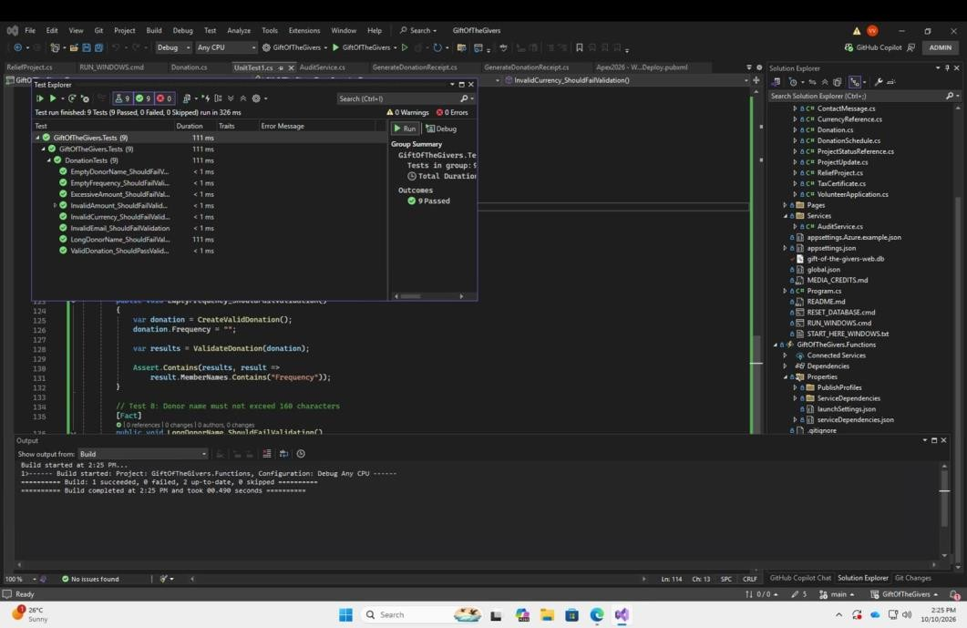
Figure 17: Unit tests passing
Description: The Test Explorer window over the code editor, showing DonationTests: 9 tests, 9 passed, 0 failed, run in 111 ms. The Output window shows a successful build.
Explanation: This is the first successful run of the unit tests. Each validation rule (empty donor name, empty frequency, excessive amount, invalid amount, currency, email, long donor name, and a valid donation) behaves as expected.

Integration Test Class
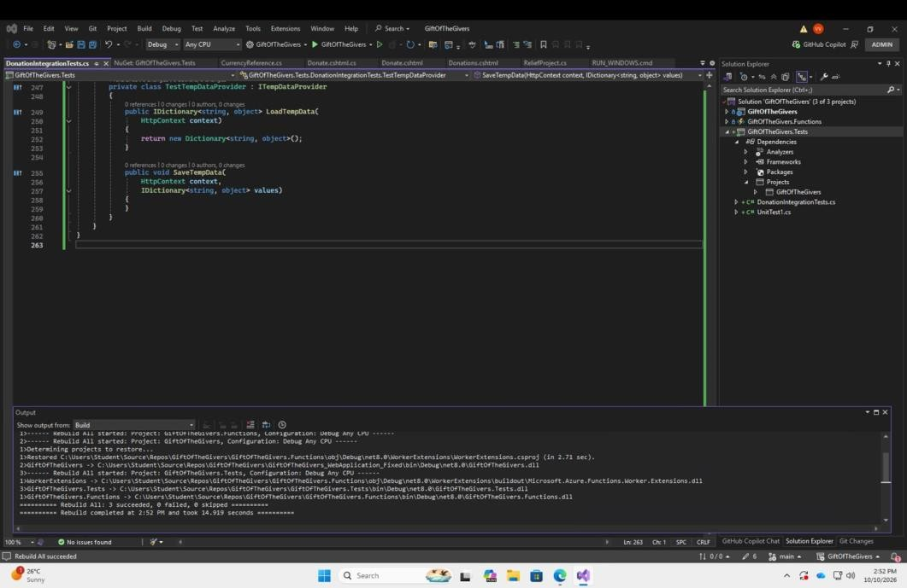
Figure 18: Integration test class
Description: DonationIntegrationTests.cs showing the helper class TestTempDataProvider, which implements ITempDataProvider with LoadTempData and SaveTempData methods. The Output window shows "Rebuild All succeeded" for all 3 projects.
Explanation: The integration tests run the application's Razor Pages in code, so they need a simple stand-in for TempData that does not depend on a real web request. The successful rebuild shows the new test class compiles with the rest of the solution.

Integratoin Tests Pass
Figure 19: Integration tests passing
Description: Test Explorer showing 18 of 18 tests passed (0 failed, 0 skipped) in about 5 seconds, including all 9 DonationIntegrationTests such as ValidDonation_ShouldSaveToDatabase, RecurringDonation_ShouldCreate... and InvalidCurrency_ShouldReject...
Explanation: This confirms the integration tests pass: donations are saved, audit logs and tax certificates are created, and invalid or inactive currencies and frequencies are rejected.

Selenium browser Testing
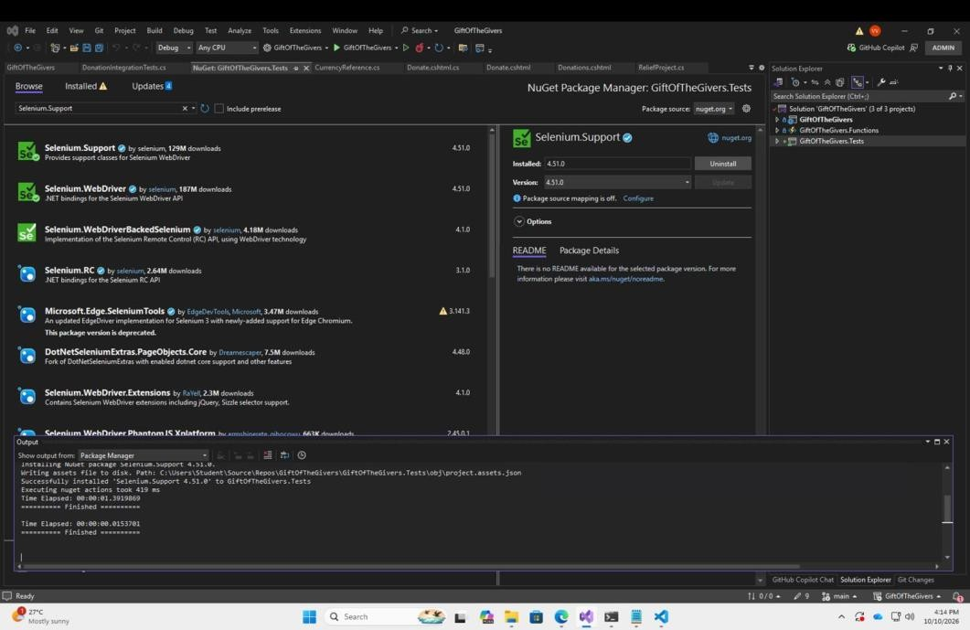
Figure 20: Selenium browser testing: installing the packages
Description: The NuGet Package Manager for GiftOfTheGivers.Tests, searching for "Selenium.Support". Version 4.51.0 is installed, and the Output window shows "Successfully installed 'Selenium.Support 4.51.0'".
Explanation: Selenium WebDriver lets the tests control a real browser. Installing these packages gives the test project the classes it needs to open pages, find elements and click buttons.

Selenium homepage test
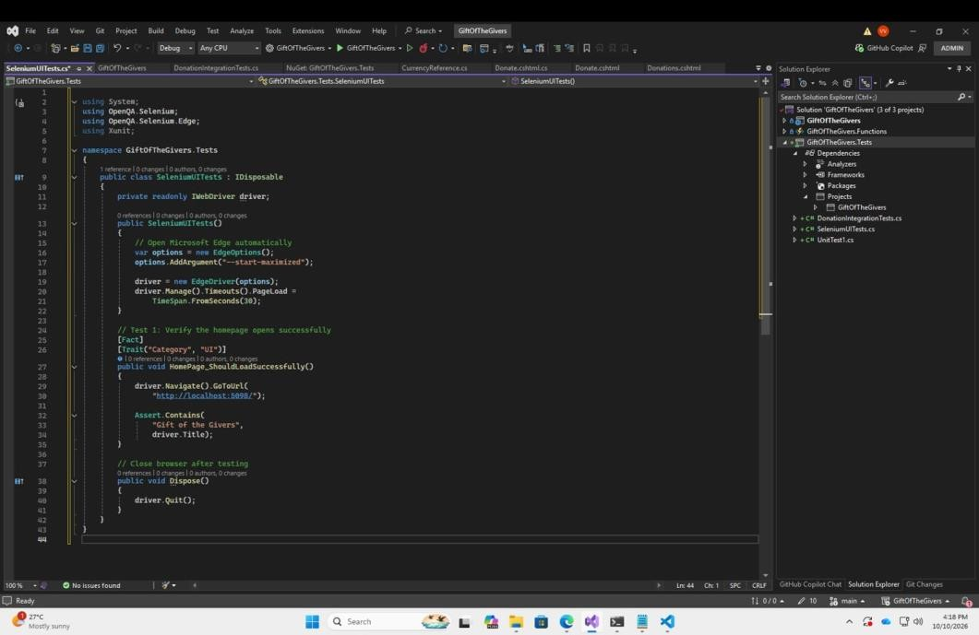
Figure 21: Selenium homepage test
Description: SeleniumUITests.cs. The constructor opens Microsoft Edge maximised with a 30-second page-load timeout. The test HomePage_ShouldLoadSuccessfully (category "UI") goes to http://localhost:5098/ and asserts the page title contains "Gift of the Givers". Dispose() closes the browser.
Explanation: This is the first browser test. It proves the site is running and that the home page loads with the right title. Implementing IDisposable ensures the browser closes after every test.
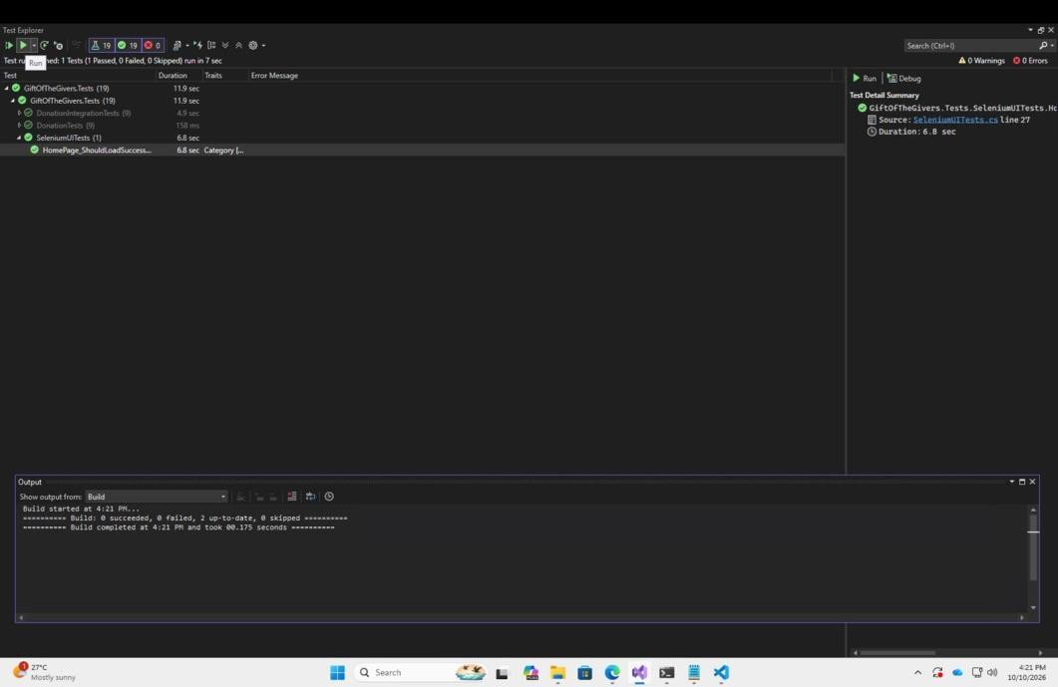
Figure 22: Running the Selenium homepage test
Description: Test Explorer after running one test: HomePage_ShouldLoadSuccessfully passed in 6.8 seconds, giving 19 tests in total, all passed. The detail panel links to SeleniumUITests.cs, line 27.
Explanation: A single UI test was run first to check that the Selenium setup works before the other browser tests were written.

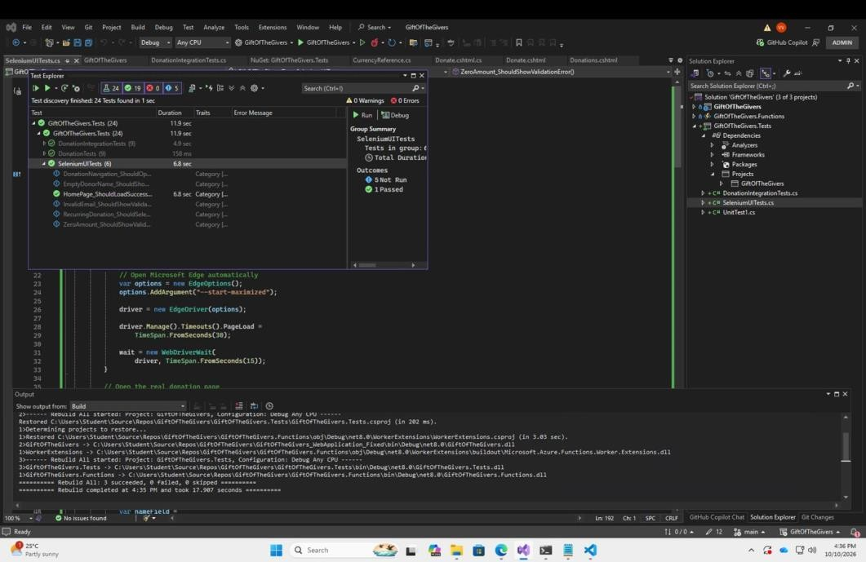
Figure 23: Selenium tests discovered
Description: Test Explorer after discovery found 24 tests. SeleniumUITests now lists 6 tests (1 passed, 5 not yet run). The code behind shows a WebDriverWait with a 15-second timeout, and the build completed successfully.
Explanation: The extra Selenium tests (donation navigation, empty donor name, invalid email, recurring donation and zero amount) were added and detected. WebDriverWait makes the tests wait for page elements to appear, which makes them more reliable.

Nuget Powershell merging configuration package success
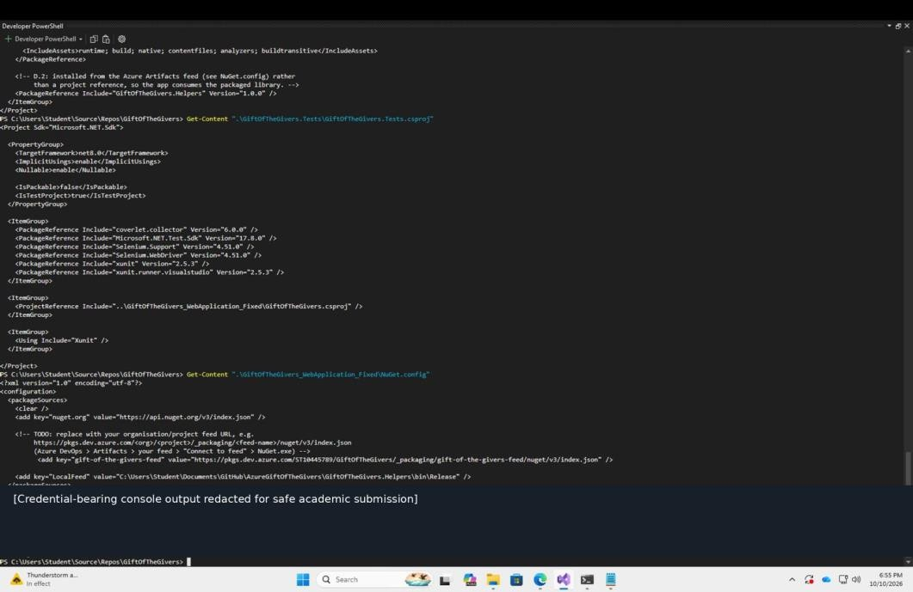
Figure 24: NuGet configuration and test project file
Description: Developer PowerShell printing the contents of GiftOfTheGivers.Tests.csproj (net8.0, xunit, Selenium.Support and Selenium.WebDriver 4.51.0, coverlet, a reference to the web project and the GiftOfTheGivers.Helpers 1.0.0 package) and NuGet.config (nuget.org, the Azure Artifacts feed and a local feed). A banner notes that credential-bearing output has been redacted.
Explanation: This shows the Helpers library is consumed as a NuGet package from the Azure Artifacts feed instead of a project reference. The credentials were removed before submission to keep the document safe.

Azure Artifact feed
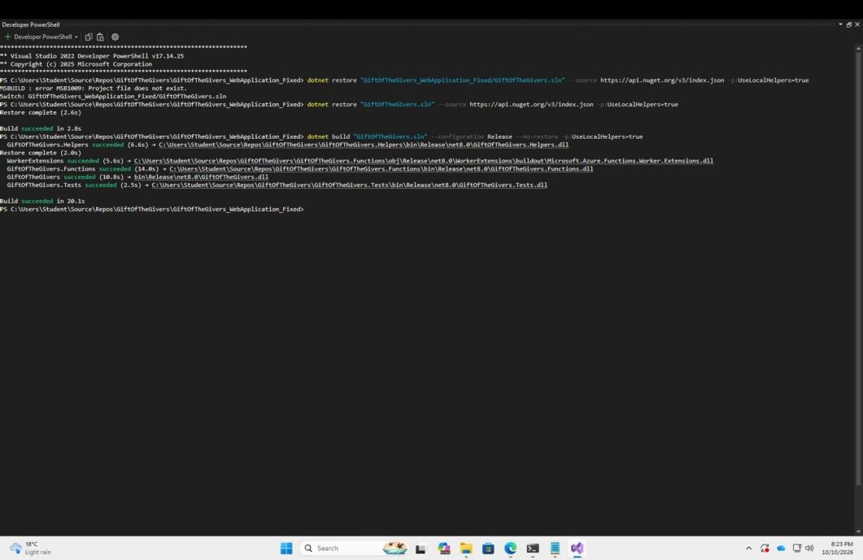
Figure 25: Restore and build succeeded
Description: Developer PowerShell. The first dotnet restore failed with MSB1009 (project file does not exist) because of the wrong folder; the second restore using GiftOfTheGivers.sln succeeded. dotnet build in Release then built Helpers, Functions, the web app and Tests, finishing with "Build succeeded in 20.1s".
Explanation: This proves the whole solution restores its packages and compiles from the command line, which is exactly what the pipeline does. The first error was only a path mistake and was fixed by running the command from the correct folder.

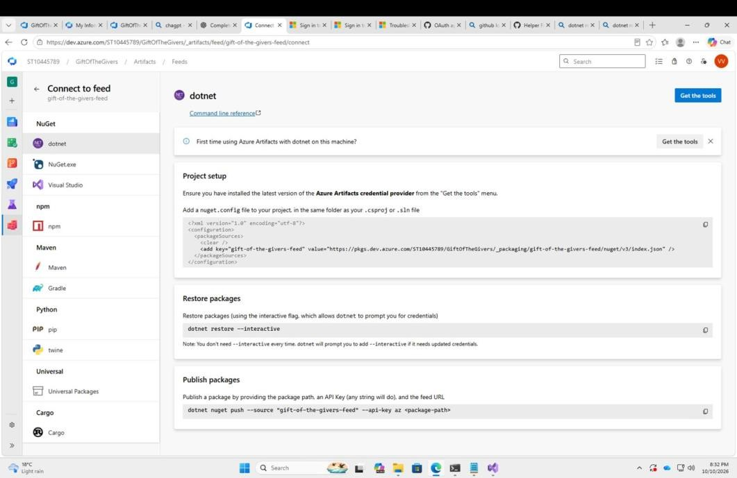
Figure 26: Azure Artifacts feed: connect with dotnet
Description: The "Connect to feed" page for gift-of-the-givers-feed in Azure Artifacts, with the dotnet tab selected. It shows the nuget.config entry to add, dotnet restore --interactive, and the dotnet nuget push command to publish a package.
Explanation: This is the setup guide for using the private feed from the .NET CLI. It gives the feed URL used in NuGet.config and the commands for restoring and publishing packages.
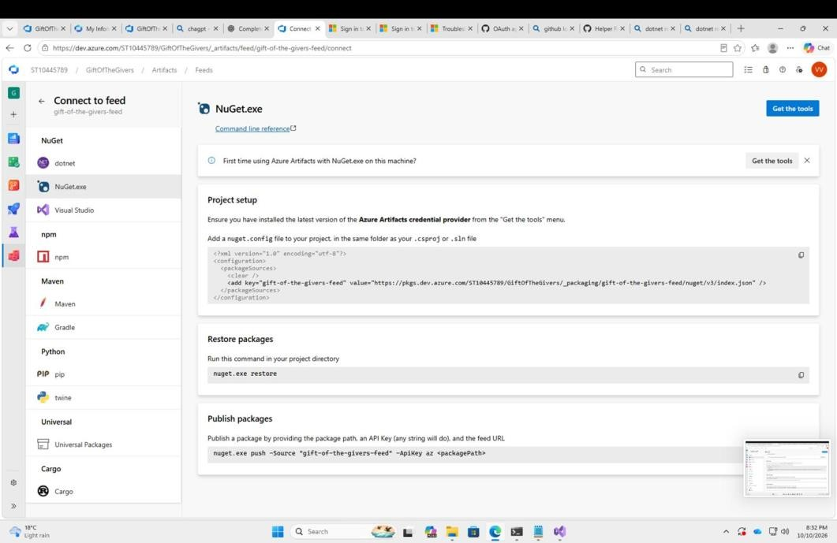
Figure 27: Azure Artifacts feed: connect with NuGet.exe
Description: The same Connect to feed page with the NuGet.exe tab, showing the same nuget.config source plus nuget.exe restore and nuget.exe push -Source "gift-of-the-givers-feed" -ApiKey az <packagePath>.
Explanation: This is the equivalent set of instructions for the NuGet command-line tool, showing that the feed works with more than one client.
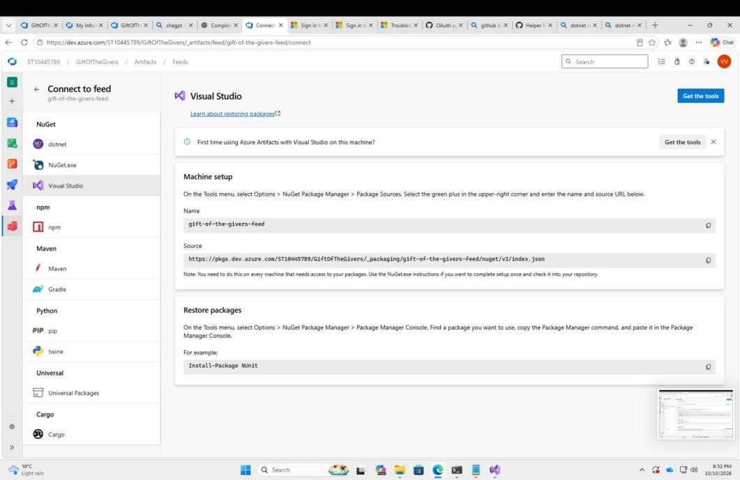
Figure 28: Azure Artifacts feed: connect with Visual Studio
Description: The Visual Studio tab of Connect to feed. The machine setup gives the feed name (gift-of-the-givers-feed) and source URL to add under Tools > Options > NuGet Package Manager > Package Sources.
Explanation: This is how the feed was registered in Visual Studio so the IDE can restore the Helpers package. It must be done on every machine that needs the package.
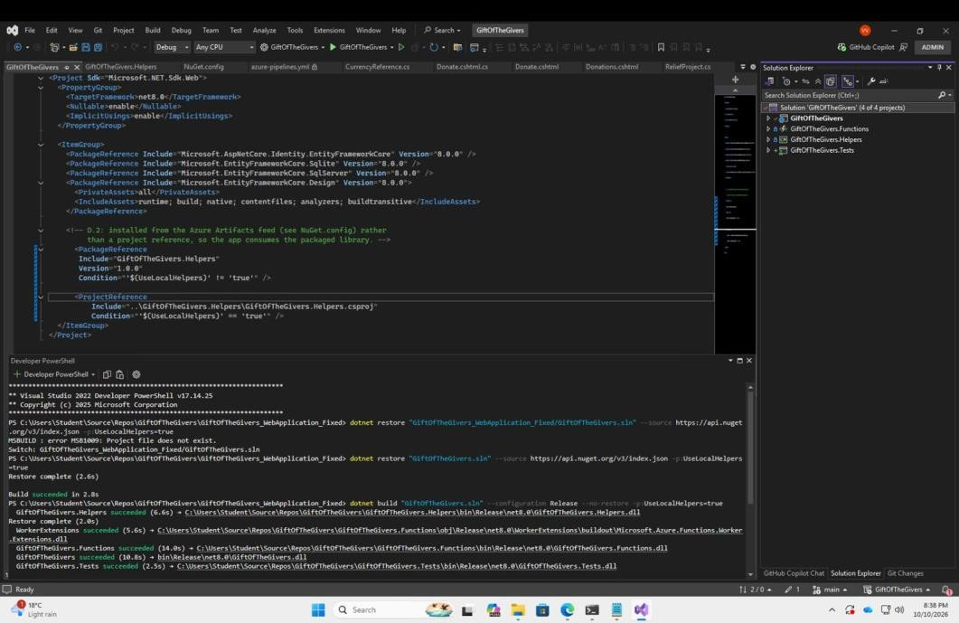
Figure 29: Helpers package reference in the project file
Description: GiftOfTheGivers.csproj open in Visual Studio. The Helpers library is added as a PackageReference (version 1.0.0) when UseLocalHelpers is not 'true', and as a ProjectReference to the local project when it is 'true'. The terminal below shows the restore and build succeeding.
Explanation: This conditional reference lets the application use the packaged library from Azure Artifacts in the pipeline, while still allowing a local project reference for development. The successful build shows both routes work.

Azure PipeLine CI YAML Config
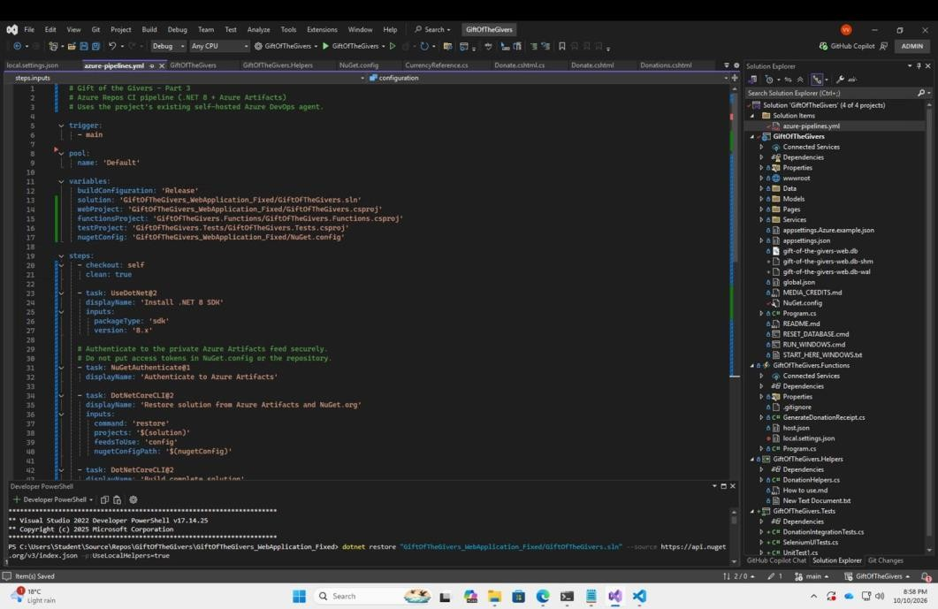
Figure 30: Azure Pipelines CI YAML configuration
Description: The top of azure-pipelines.yml: it triggers on the main branch, uses the "Default" agent pool, defines variables (buildConfiguration Release, solution, webProject, functionsProject, testProject and nugetConfig paths), and the first steps are checkout, UseDotNet@2 (.NET 8 SDK) and NuGetAuthenticate@1.
Explanation: This is where the CI pipeline starts. Variables keep the paths in one place, and the authentication step lets the pipeline securely read the private Azure Artifacts feed.

YAML security checks
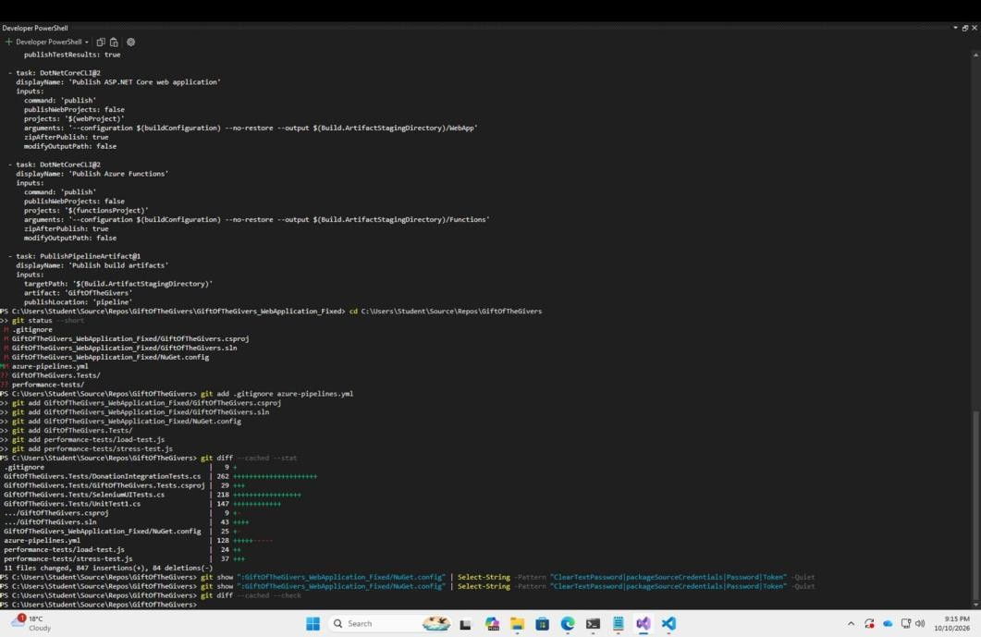
Figure 31: YAML security checks
Description: The end of the pipeline YAML (publish the web app and the Azure Functions as zip files, then PublishPipelineArtifact), followed by git status, git add, git diff --cached --stat, a Select-String search of NuGet.config for ClearTextPassword, packageSourceCredentials, Password and Token, and git diff --cached --check.
Explanation: These checks ensure no passwords or access tokens were committed. The search returned nothing, so the feed is authenticated through the pipeline task rather than secrets in the repository. The final steps publish the deployable artifacts.

WEBSITE



